Lab - Convert Data into a Universal Format

Part 1: Normalize Timestamps in a Log File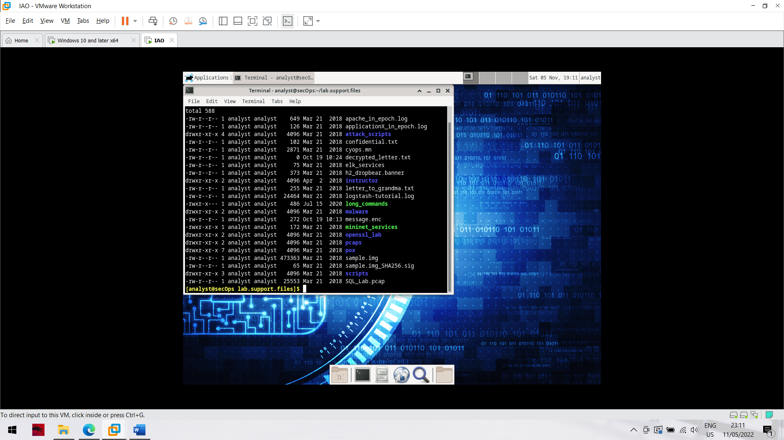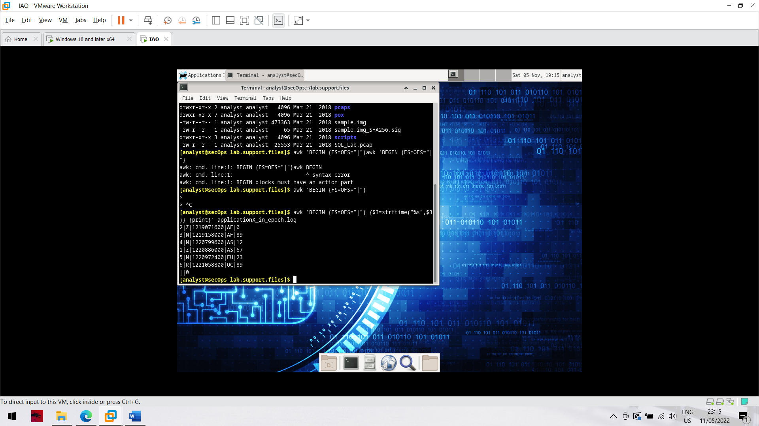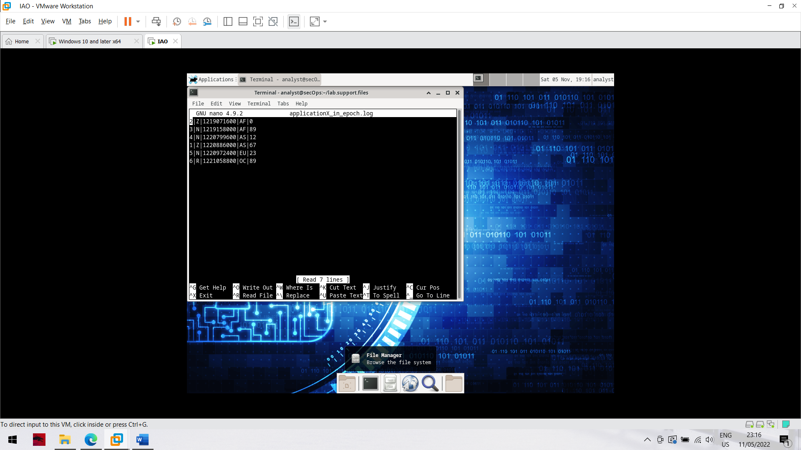

Part 2: Normalize Timestamps in an Apache Log File

